**Week 8 : HandsOn Excercise**

1) Familiar with Git commands like git init, git status, git add, git commit, git push, and git pull

a.Git Configuration and Setup

b.Notepad++ Integration

c.Add a file to source code repository

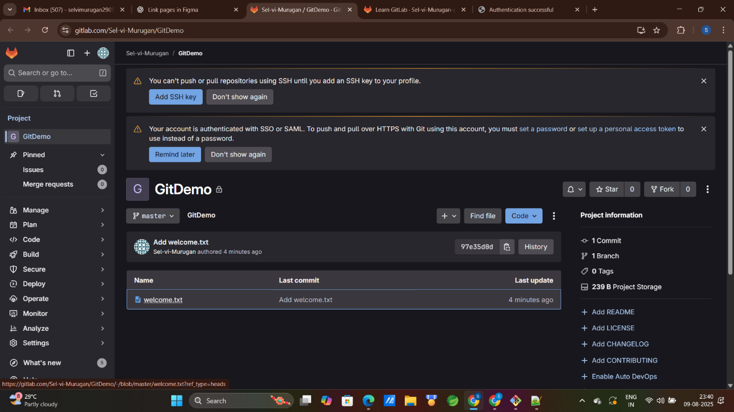

1. Implement git ignore command to ignore unwanted files and folders

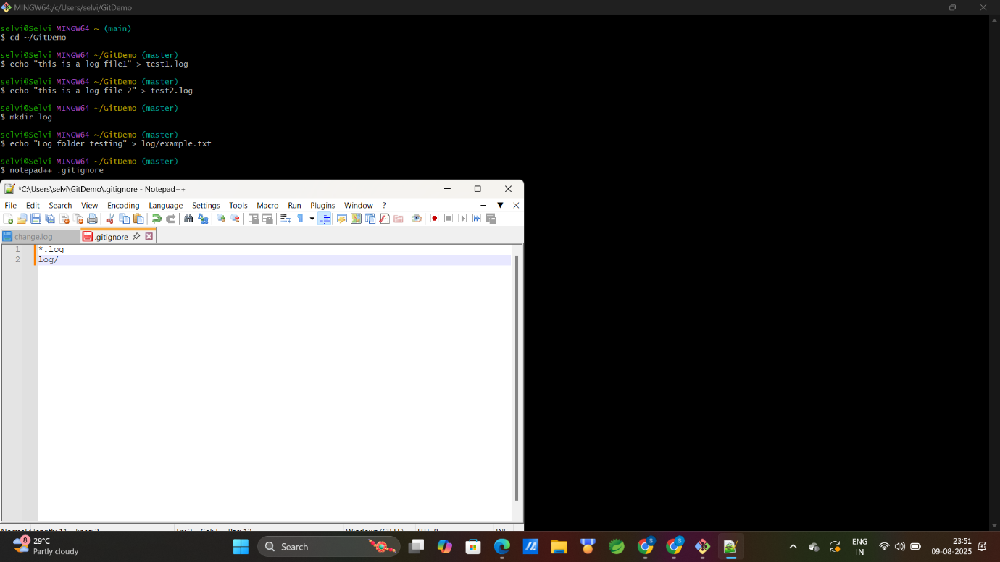

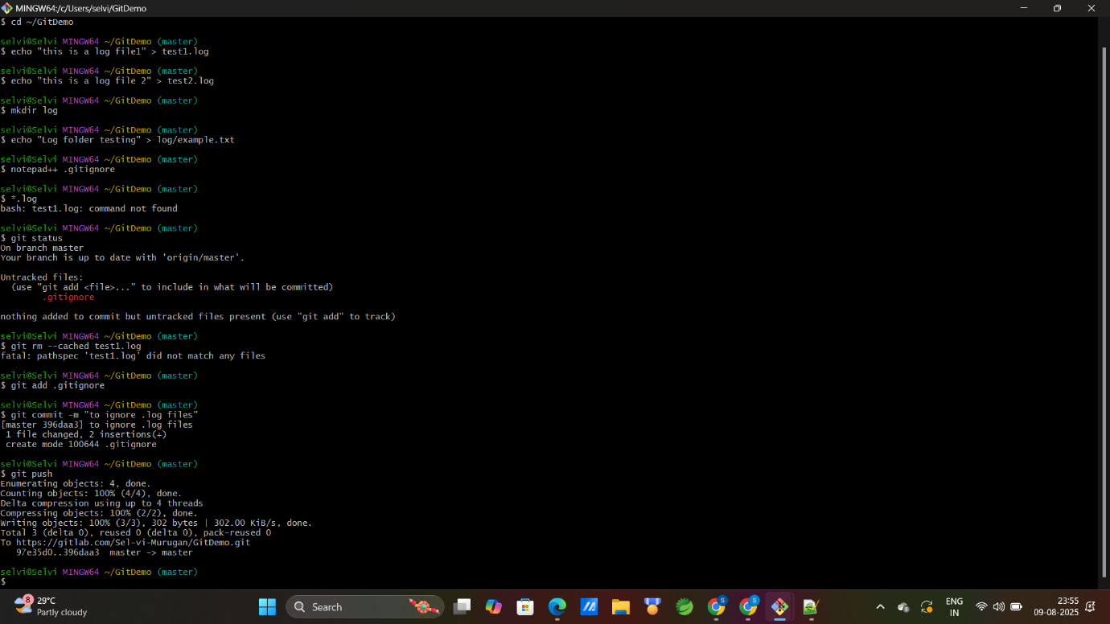

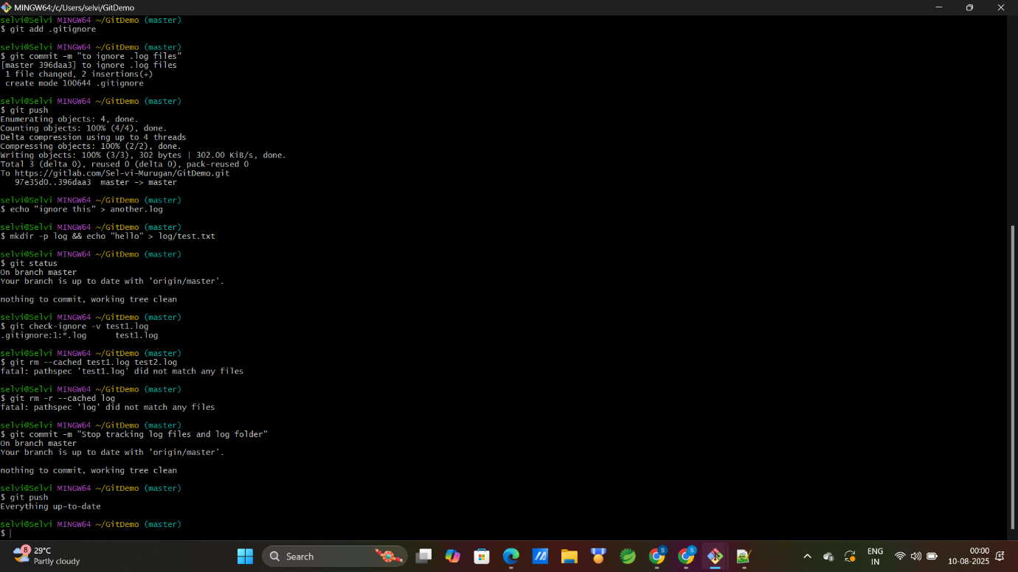

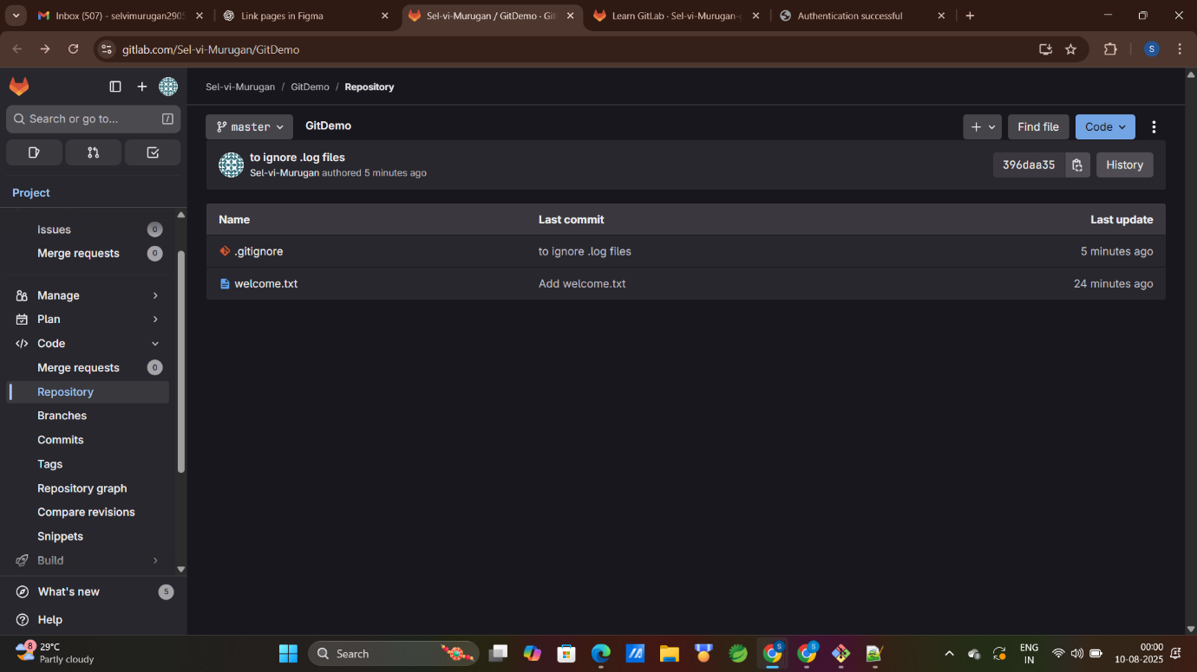

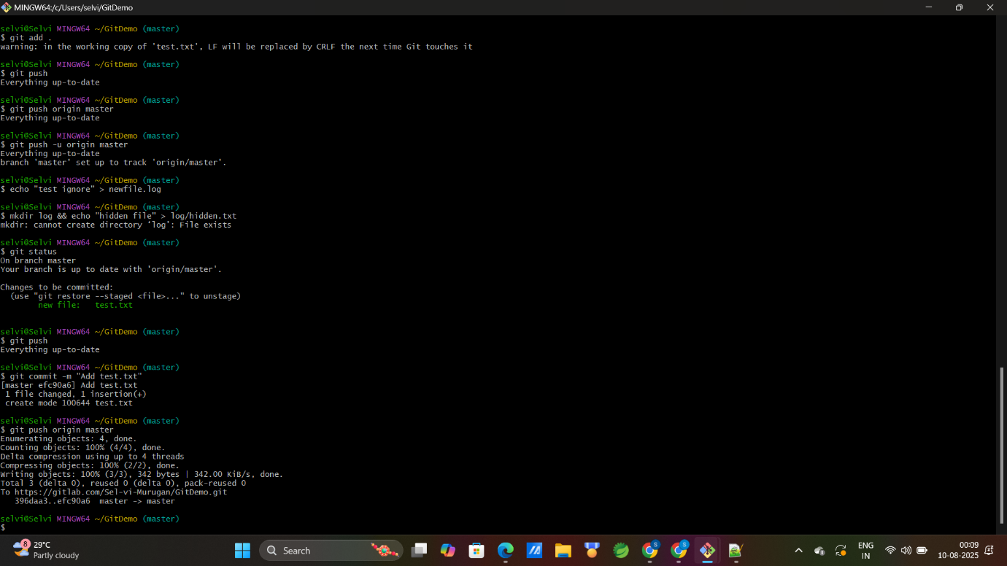

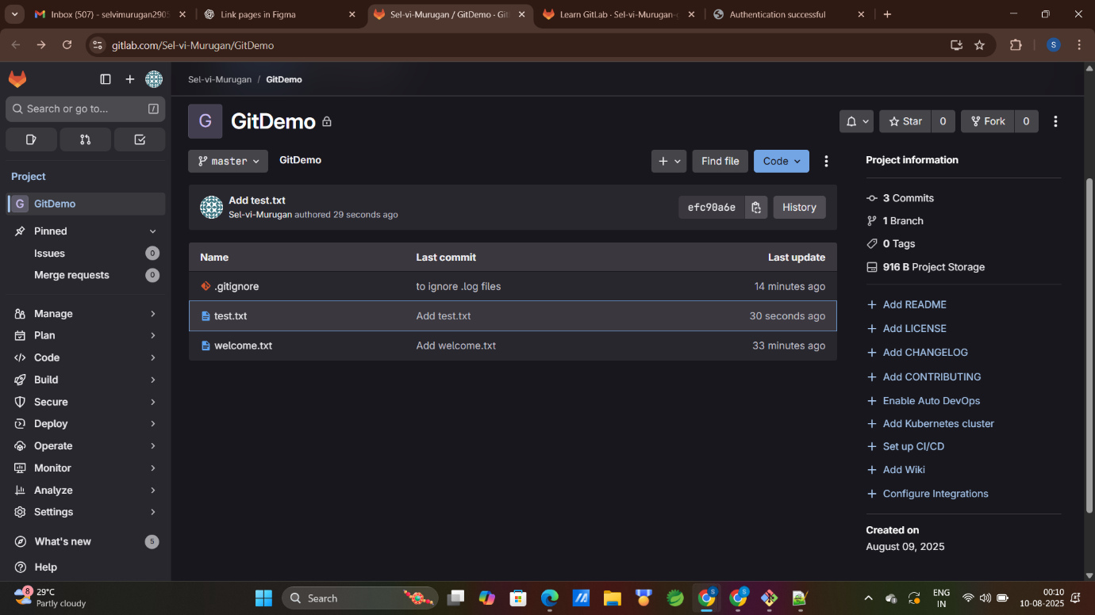

3)Construct a branch, do some changes in the branch, and merge it with master (or trunk)

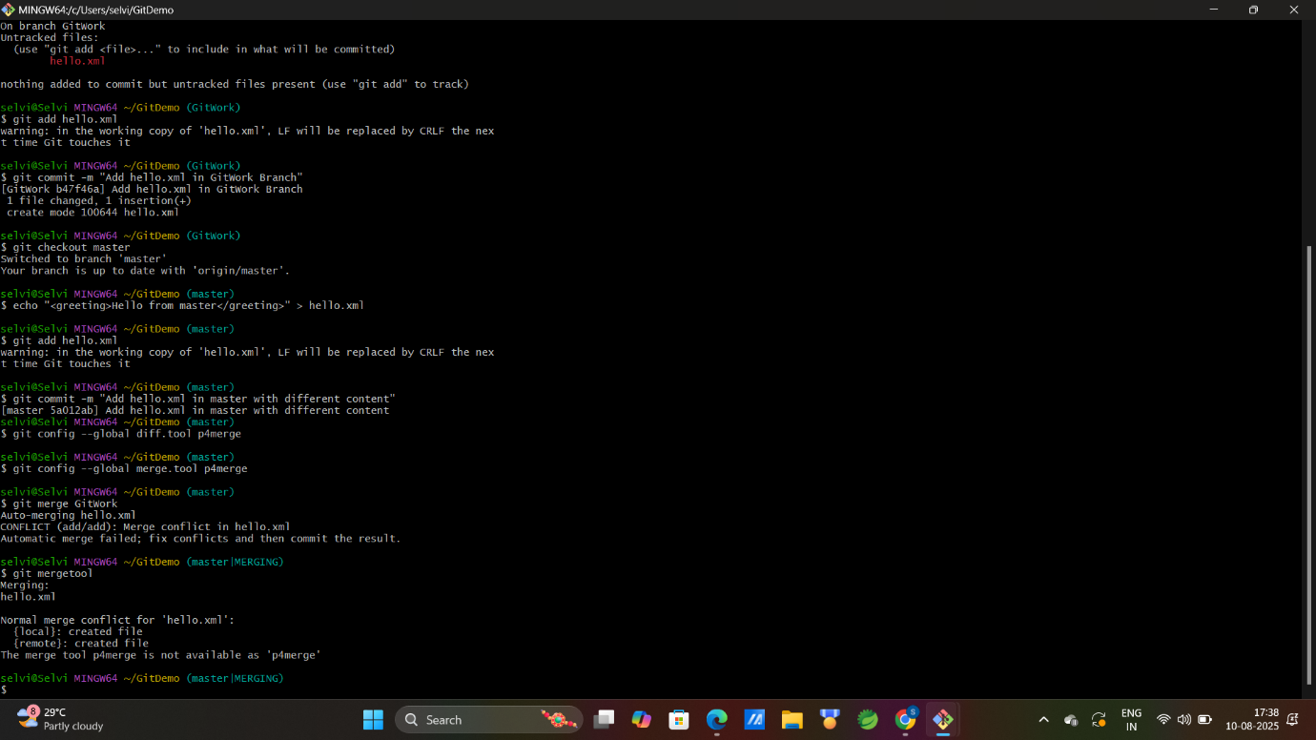

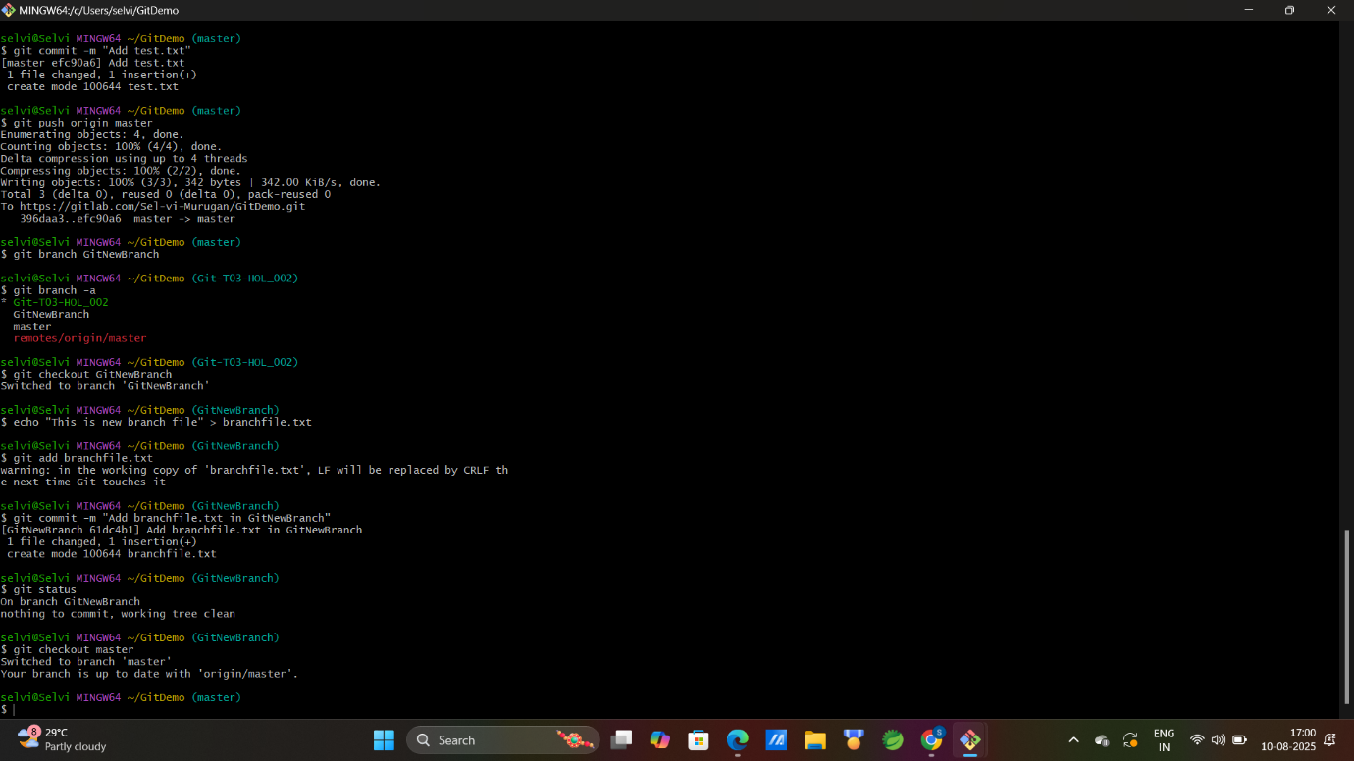

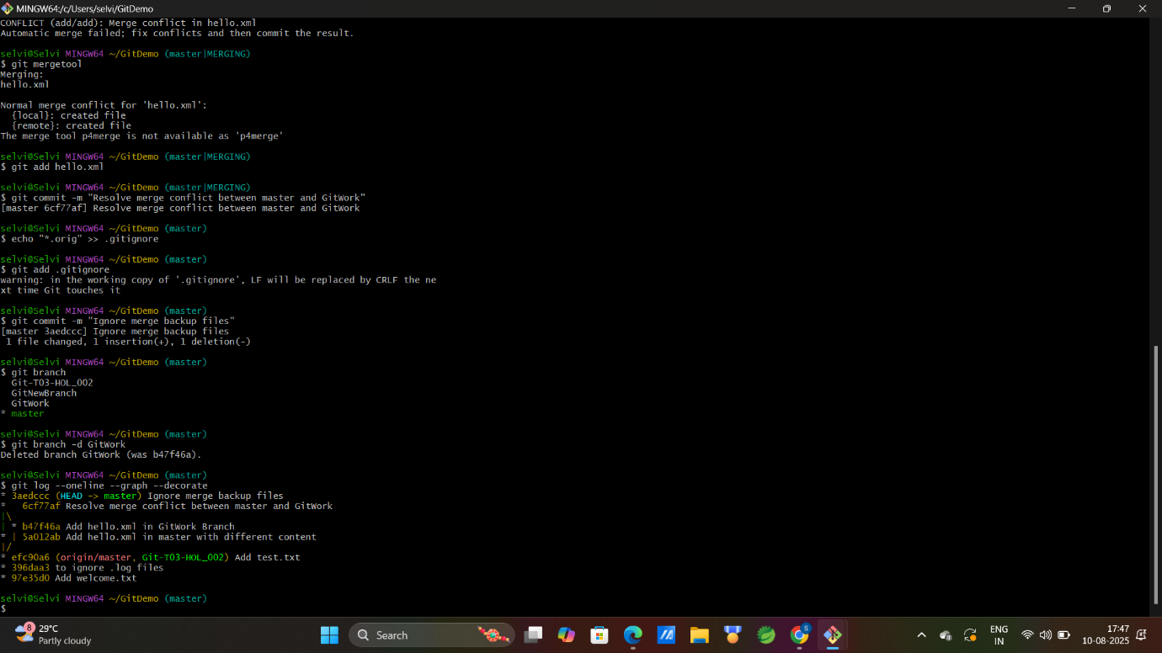

4)Implement conflict resolution when multiple users are updating the trunk (or master) in such a way that it results into a conflict with the branch’s modification.

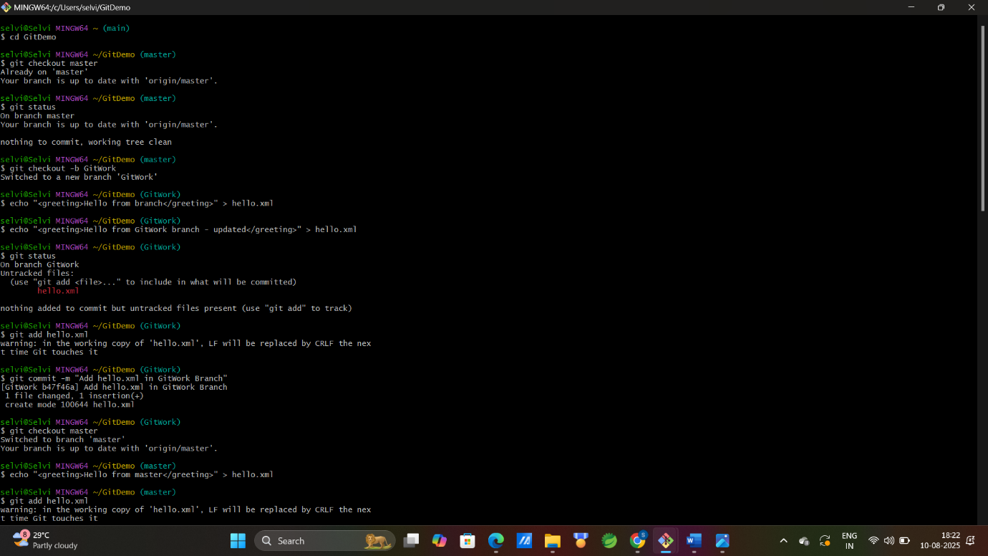

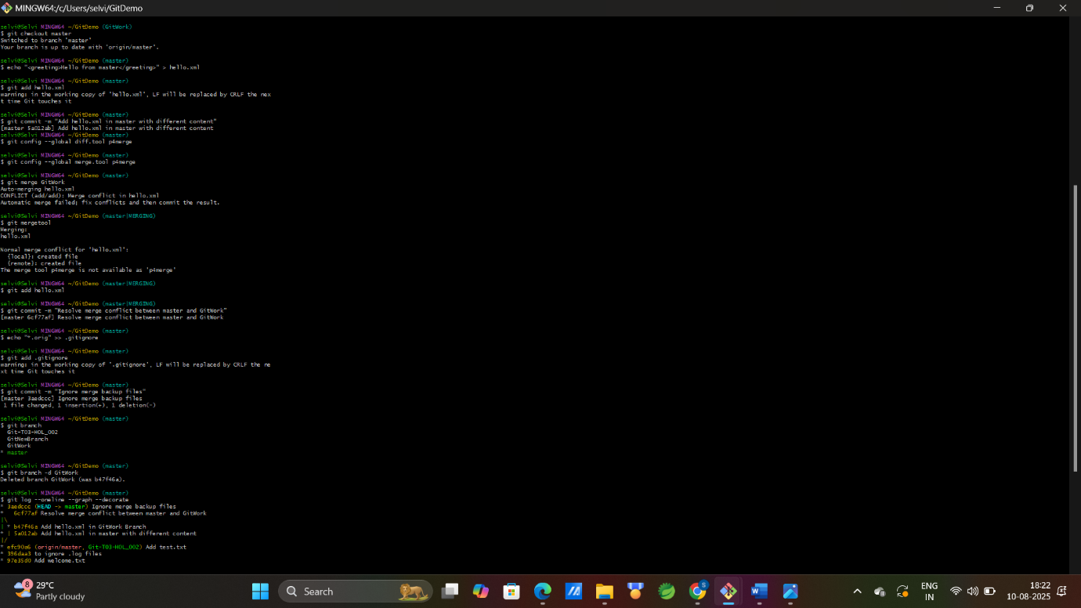

5) Execute steps involving clean up and push back to remote Git.

